MDX Emerging Technologies showcase 2024

ANDREI RUTTY

M00941399

Table of Contents

Problem Statement 2

Function 3

Features 3

Electrical Design 4

Test Results 5

Table of Figures

Figure 1 - Circuit Diagram 4

Table of Tables

Table 1 - Pinout table 4

Table 2 - Component Testing Table 6

Table 3 - Functional Testing Table 7

Table 4 - System Testing Table 7

## Problem Statement

Pollution is rapidly tarnishing our planet causing silent but dreadful impact on the environment, human health, and our biodiversity. In Europe alone, 1 out of 10 premature deaths are attributed to pollution, with citizens suffering from respiratory and cardiovascular diseases due to poor air quality. Moreover, poor waste management aggravate the situation, with astonishing statistics revealing the considerable scale of plastic waste and its detrimental effects on the ecosystem with biodiversity loss and ecological consequences and people’s health. Urgent action is imperative to combat pollution’s threats and safeguard the planet for the future generations.

Recycling robots offer a solution to significantly improve the efficiency of waste management. Compared to humans, recycling robots provide outstanding recycling rate (92-99%) and can achieve an hourly picking rate of around 2000 to 4000 picks, though hindered by high cost which can come close to $300, 000.

Developing a low-cost and autonomous recycling robots promises equitable access to efficient waste management, contributing towards a cleaner and healthier environment.

## Function

My recycling robotic system is equipped with the following functions:

* Classifying items based 5 categories (Paper, Plastic ,Glass/Metal, Organic and Other)
* Ensuring the item is within the range of the robot.
* Moving and rotating the robotic arm.
* Handling the item using a robotic arm.
* Dropping the item in its corresponding bin.

## Features

* Utilizes computer vision with OpenCV and a pre-trained waste classification AI system to classify items based on live footage from the camera.
* Features an autonomous robotic arm capable of handling and dropping items in the correct bin with movement abilities in the forward and backward direction and to rotate through 180 degrees along the z-axis.
* Equipped with an infrared sensor that constantly detect the presence of an item within a certain range and an ultrasonic sensor that measures the distance from the item to the robotic arm, ensuring the item is within reach of the robotic arm.
* A voice feedback system that alerts the user that an item is not within the range and to bring it closer to the robotic arm reach.

## Electrical Design

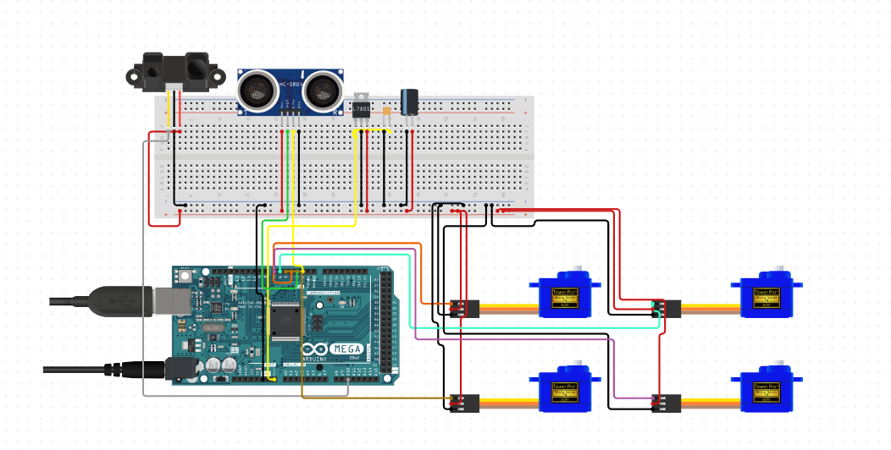

B

C

A

D

Figure 1 - Circuit Diagram

Index:

1. Arduino Mega 2560 Rev3
2. SG 90 Micro Servos
3. HR-SR04 Ultrasonic Sensor
4. IR Sensor Module

*Pinout Table for Arduino Mega 2560 Rev3*

|  |  |
| --- | --- |
| **Component** | **Pin Number** |
| IR Sensor Module | 5 (Digital Pin) |
| HR-SR04 Echo | 6 (Digital Pin) |
| HR-SR04 Trigger | 7 (Digital Pin) |
| Servo 1 | 8 (Digital Pin) |
| Servo 2 | 9 (Digital Pin) |
| Servo 3 | 10 (Digital Pin) |
| Servo 4 | 11 (Digital Pin) |

Table 1 - Pinout table

## 

## Test Results

The tables below show the different types of testing performed to ensure smooth operation of Sort X.

*Component Testing*

|  |  |  |
| --- | --- | --- |
| **Component** | **Requirements** | **Actual Output** |
| Arduino Mega 2560 Rev 3 | * Process instruction uploaded via the Arduino IDE * Communicate with actuators (servo motors) * Communicate with sensors (ultrasonic and infrared) * Communicate with the object classifier script written in Python through serial port. | * Successful instruction uploads to Arduino board. * Successful communication between board and actuators * Successful communication between board and sensors * Successful communication through serial port between board and object classifier script. |
| SG 90 Micro Servo | * Communicate with Arduino board. * Smooth and stable rotation * Accurate rotation through given angle provided by Arduino board | * Successful communication between servo and Arduino board. * Smooth and stable rotation for all 4 servos. * All 4 servos accurately rotate through given angle |
| HR-SC04 Ultrasonic Sensor | * Communicate with Arduino board. * Read and display object distance from sensor. * Send data to object classifier script through serial port | * Successful communication between sensor and Arduino board * Successful reading and display of object distance in real-time. * Successful sending of data to object classifier script through serial port |
| IR Sensor Module | * Communicate with Arduino board. * Detect presence of objects within line of sight * Send data to object classifier script through serial port | * Successful communication between sensor and Arduino board * Successful detection of objects within line of sight * Successful sending of data to object classifier script through serial port |
| Logitech Webcam | * Connection established with the computer. * Provide live footage for object classifier script written in Python using OpenCV for classifying items based on their material(Plastic, Paper, Metal etc..) * Communicate with Arduino board when sensors detect an object | * Successful connection with computer * Successful provision of live footage for object classifier * Successful communication with Arduino board when sensors detect an object |

Table 2 - Component Testing Table

*Functional Testing*

|  |  |  |
| --- | --- | --- |
| **Function** | **Requirements** | **Actual Output** |
| Communication between Arduino board and object classifier script | * Communication between both parties establish through serial port. * Arduino board to send and receive data from object classifier script. * Object classifier script to send and receive data from Arduino board. | * Successful communication between both parties * Successful communication from and to object classifier script * Successful communication from and to Arduino board |
| Live camera footage | * Object classifier script can detect and use webcam live footage. * Using OpenCV for object classifier | * Successful webcam detection and usage * Successful classification of objects into the 3 main categories (Paper, Plastic and Metal) |
| Detect item presence (Python Script) | * Establish connection with Arduino board. * Receive data from sensors. * Process information and send result to object classifier script * Activate voice feedback for invalid data | * Successful connection establishes with Arduino board. * Successful receipt of data from sensors * Successful data processing and sending result to object classifier script * Successful activation of voice feedback for invalid data |
| Move Robotic Arm  (C++ Arduino code) | * Establish connection between object classifier script * Receive data from script. * Activate robotic arm and start item handling based on data received. * Communicate feedback to object classifier script | * Successful connection established between the parties * Successful receipt of data from script * Successful robotic arm activation and item handling * Successful feedback communication to script |

Table 3 - Functional Testing Table

*System Testing*

|  |  |  |
| --- | --- | --- |
| System | Requirements | Result |
| Item classification and handling (Whole system function) | * Detection of an item placed within acceptable range. * Correct classification of item material * Robotic arm activation and item handling * Item disposal in respective bin * Robotic arm returning to idle state | Test pass but object classifier can have difficulties in classifying item in poor lighting environment. |
| Robotic arm manoeuvre upon item classification | * Robotic arm extends forward. * The claws open and fetch the item. * Robotic arm base rotates towards the corresponding bin * Claws open and dispose the item * Robotic arm returns to idle state | Test pass but something the base rotation isn’t very smooth. |
| Item handling upon item classification | * Claws open to fetch item from user. * Claws open to dispose the item in correct bin. | Test pass but bigger and wider objects can not be handled by the claws. |
| Item distance and presence verification prior to item classification | * Detecting presence of an item * Verifying that the item is within the correct range * Alert the user is object is not within the range | Test pass but has a 2 second delay. |

Table 4 - System Testing Table